ICS-344 - Information Security
Section 02
Ali Kamal Aloryd 202322750
Redha Abdulaziz Alturaik 20232301
http://dvsa-website-test-546079881937-us-east-1.s3-website.us-east-1.amazonaws.com/
us-east-1 (N. Virginia)
Date: 19 April 2026
Event Injection
Lesson - 1

Goal and Vulnerability Summary
The goal of this lesson is to demonstrate an Event Injection vulnerability in the DVSA serverless application. This vulnerability allows attacker-controlled input to be processed unsafely by the backend Lambda function. By exploiting this flaw, an attacker can inject malicious code into the request, which may be executed during deserialization. The objective is to achieve Remote Code Execution (RCE) and verify it through backend logs.

Why This Works / Root Cause
The vulnerability is caused by unsafe deserialization of user input using the node-serialize library. The backend Lambda function unserializes attacker-controlled data using serialize.unserialize(event.body), which allows specially crafted payloads containing executable JavaScript functions (e.g., _$$ND_FUNC$$_) to be executed. Since the application does not validate or sanitize input before deserialization, it treats malicious input as executable code, leading to Remote Code Execution.

Environment and Setup
The DVSA application is deployed in AWS (us-east-1) using API Gateway, AWS Lambda, and DynamoDB. The vulnerable component is the DVSA-ORDER-MANAGER Lambda function, which processes requests sent to the /order API endpoint. The testing environment includes the AWS Console for monitoring logs via CloudWatch and a Kali Linux terminal to send crafted HTTP requests using curl. The Lambda runtime was configured to Node.js 20.x to ensure compatibility with the legacy callback-based handler used in the application.

Intended Logic & Workflow
In the normal workflow, a user submits an order through the DVSA frontend hosted on Amazon S3. The request is sent to Amazon API Gateway, which acts as the entry point. API Gateway forwards the request to the AWS Lambda function (DVSA-ORDER-MANAGER), which processes the request. The Lambda function parses the request body, validates the input fields (such as action and cart-id), and verifies authorization before executing business logic. The function then interacts with Amazon DynamoDB to store or retrieve order data and returns the result to the client. Security checks that should occur include strict input validation, safe parsing of JSON data using JSON.parse(), and ensuring that user input is never executed as code.

Reproduction Steps
Step 1 - Get API Endpoint:
- Log in to AWS Console
- Navigate to API Gateway
- Select the DVSA API
- Click “Stages”
- Open the active stage
- Copy the Invoke URL
- Append “/order” to the URL

Step 2 - Send Malicious Payload (Event Injection):
- Open Kali Linux terminal
- Run the curl command below:
curl -X POST "Your API " \
-H "Content-Type: application/json" \
-H "Authorization: Bearer dummy_token" \
-d '{"action":"_$$ND_FUNC$$_function(){console.error(\"PWNED\")}()","cart-id":""}'
- Observe the response in terminal
Step 3 - Verify Execution:
- Go to CloudWatch
- Navigate to Log Groups
- Open /aws/lambda/DVSA-ORDER-MANAGER
- Open the latest log stream
- Locate the injected log output

Evidence and Proof
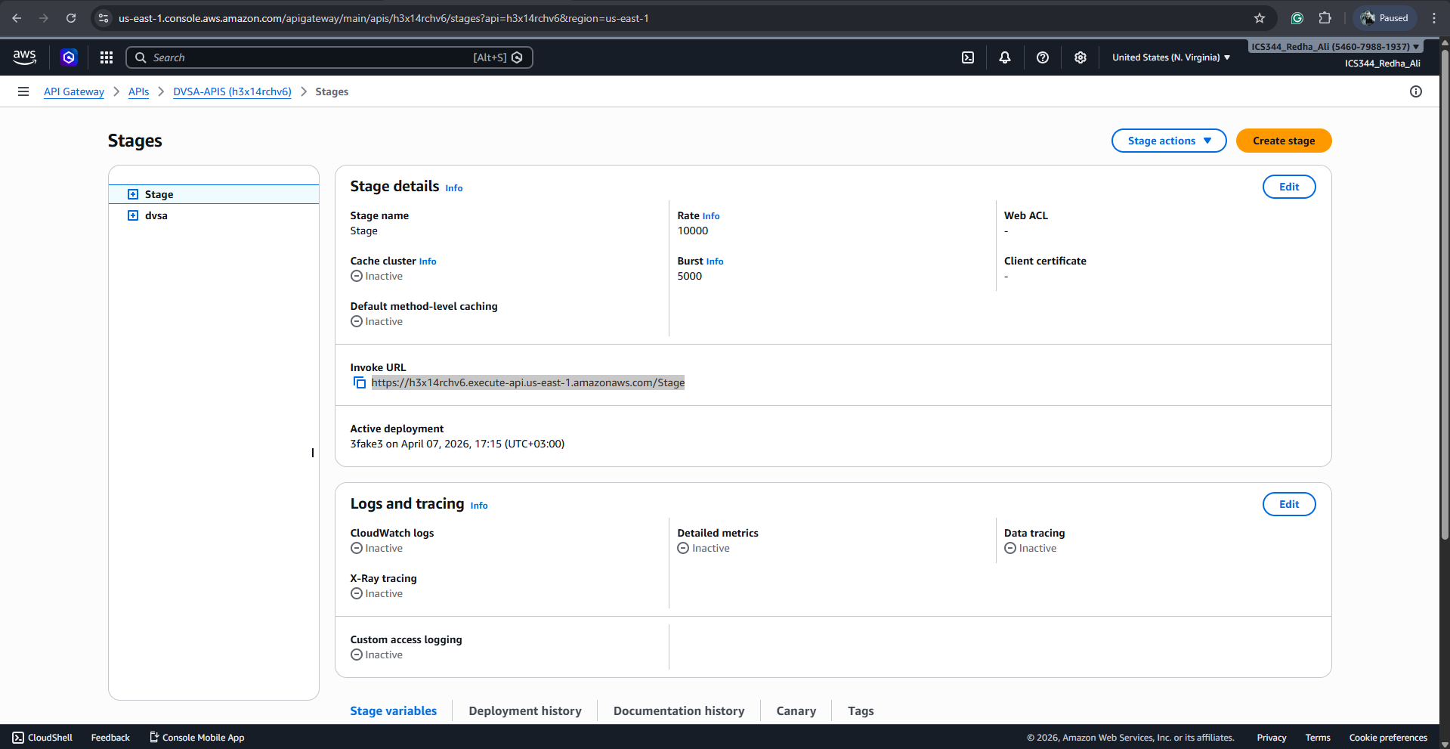
Figure 1. Invoke URL
The malicious payload was sent successfully using a crafted API request. The API returned an "Internal server error", which is expected behavior. It is important to note that although the API returned an "Internal server error", the exploit was still successful. The malicious code executed before the application crashed, and this execution is confirmed through CloudWatch logs.
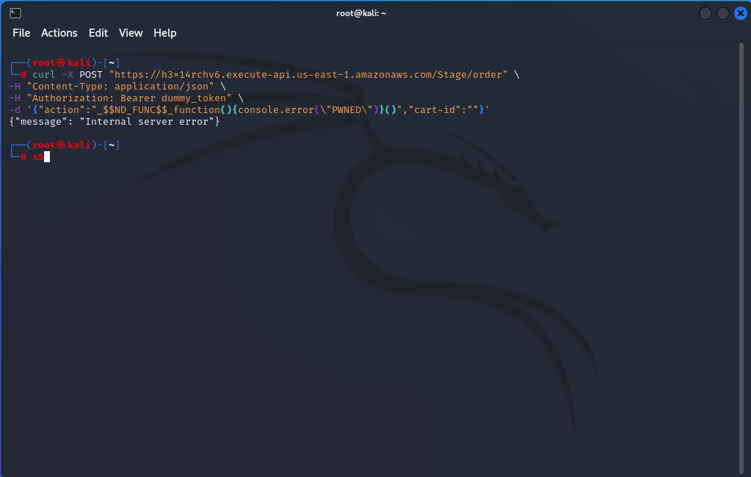
Figure 2. Malicious Payload

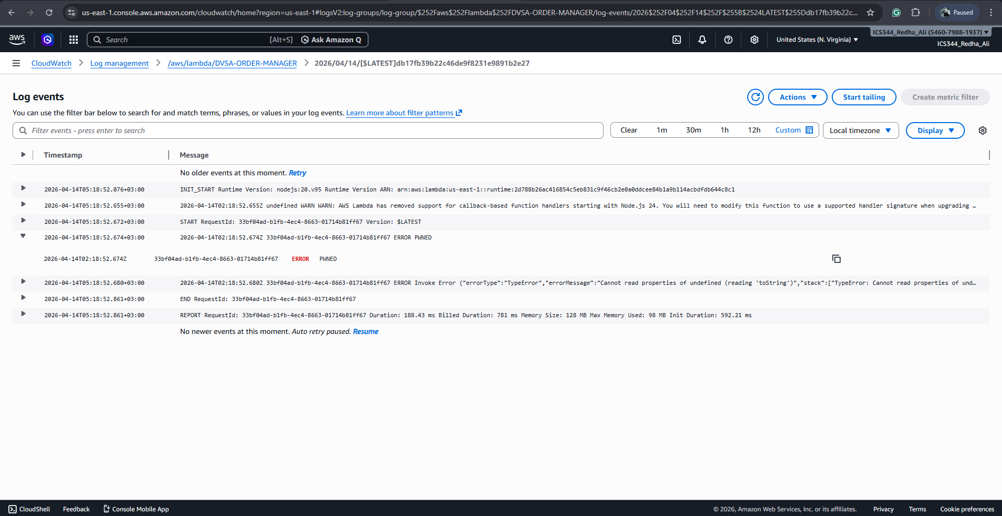
Figure 3. Log output
CloudWatch logs confirm that the payload executed successfully, as shown by the presence of the log entry "PWNED". This proves that attacker-controlled input was executed inside the Lambda function. Therefore, the application is vulnerable to event injection, resulting in Remote Code Execution.

Fix Strategy / Probable Mitigation
The vulnerability can be mitigated by removing unsafe deserialization and ensuring that all user input is treated strictly as data. The application should avoid using libraries such as node-serialize that allow execution of serialized functions. Instead, input should be parsed using safe methods such as JSON.parse(), combined with strict validation and allowlisting. Additionally, user input should never be executed as code.

Code / Config Changes
Before (vulnerable):
const serialize = require('node-serialize');
var req = serialize.unserialize(event.body);
var headers = serialize.unserialize(event.headers);
After (secure):
const req = typeof event.body === "string" ? JSON.parse(event.body) : event.body;
const headers = event.headers || {};
if (!allowedActions.includes(req.action)) {
throw new Error("Invalid input");
}

Verification After Fix
After applying the fix, the same malicious payload was sent again. The system no longer executed the injected code, and no "PWNED" message appeared in CloudWatch logs. This confirms that the fix successfully prevents execution of attacker-controlled input while maintaining normal application behavior.

Structured Operation and Security Analysis

Table 1: Structured analysis summary — Table A
Vulnerability | Intended Rule(s) | Artifacts Used to Infer Rule | Normal Behavior Evi dence | Exploit Behavior Evi dence
Event Injection | Input must not be executed as code; only validated JSON should be processed | API request, CloudWatch logs, Lambda execution | Request processed without executing input | Injected payload executed and logged (“PWNED”)

Table 2: Structured analysis summary — Table B:
Vulnerability | Why This Is a Deviation | Deviation Class | Fix Applied  (where) | Post-Fix Verification
Event Injection | The system executed attacker-controlled input instead of treating it as data | Intentional misuse / security-relevant abuse | Removed unsafe deserialization in Lambda (DVSA-ORDER-MANAGER) | No execution in logs after fix

Takeaway / Lessons Learned
This lesson demonstrates the critical risk of unsafe deserialization in serverless applications. By exploiting the use of node-serialize, attacker-controlled input was executed inside the Lambda environment, resulting in Remote Code Execution. This highlights the importance of secure input handling, avoiding vulnerable dependencies, and enforcing strict validation. Developers must ensure that user input is never interpreted as executable code to prevent severe security breaches.

